Chapter 4 Generics

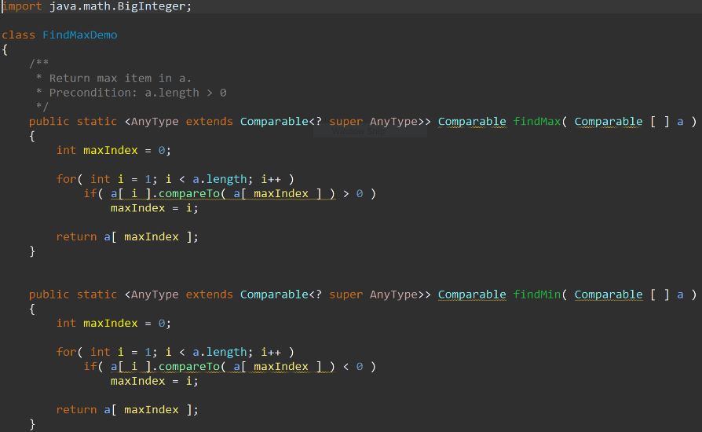**4.23 and 4.21:**

here is the code for the max and min and also the main with the test which shows that it is working. I found the max and min of the list and it was correct with the outputs I had.

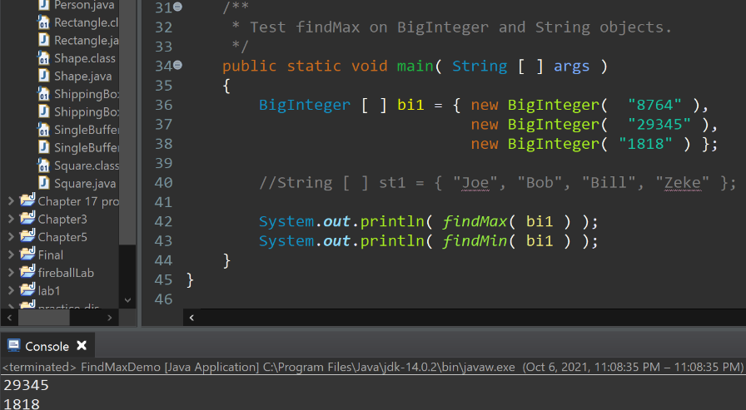

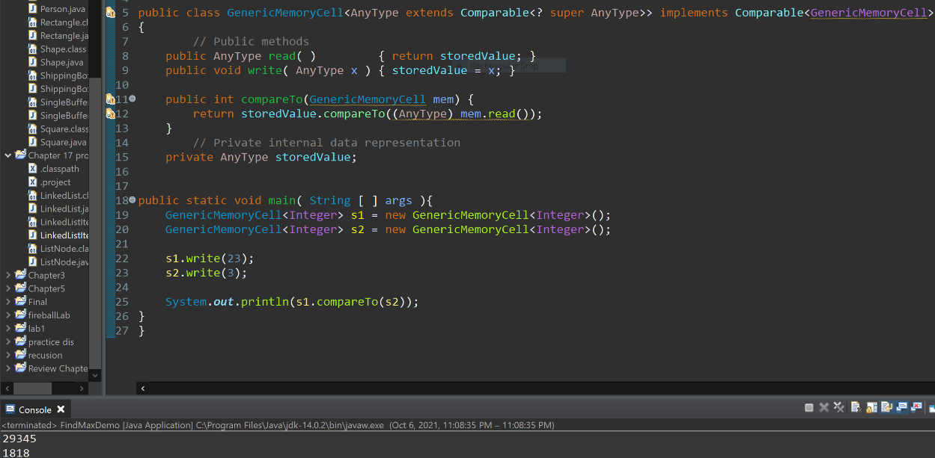**4.29:**

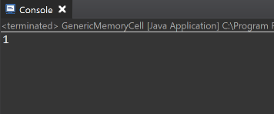Here is the code and I test it with a main to see if the answer was right and it was since they weren’t the same and s1 was not the same then it returns a 1.

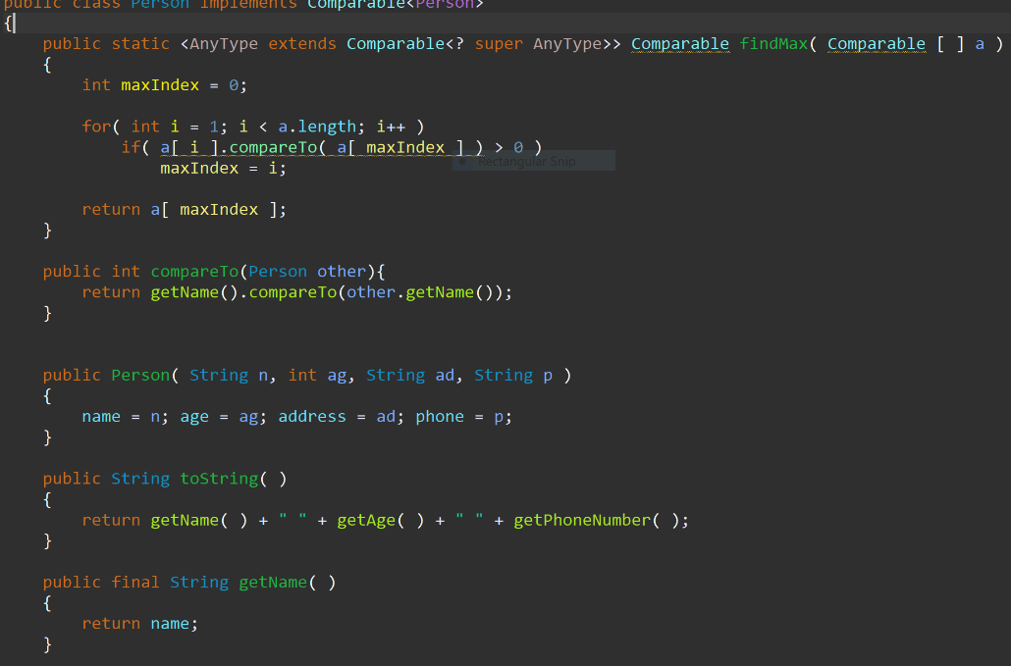**4.36:**

The code with person also the main to test out everything and it works. Also do test compare too. I am getting the right answer only thing I am returning -14 instead of just -1.

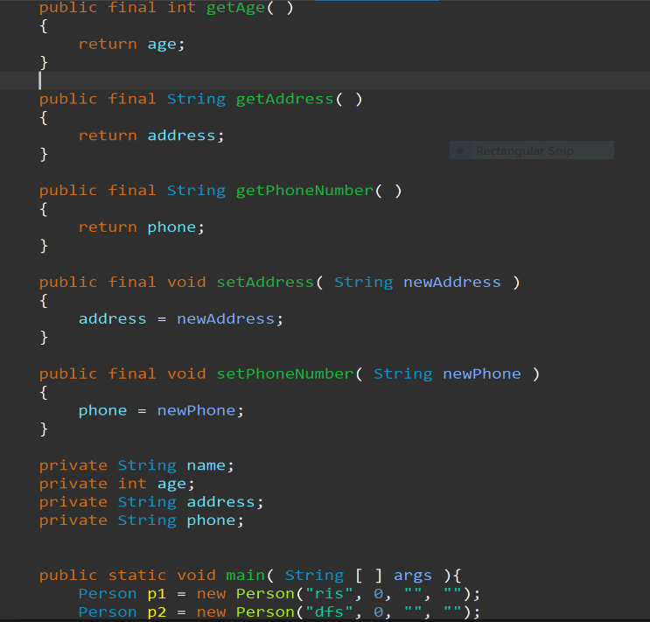

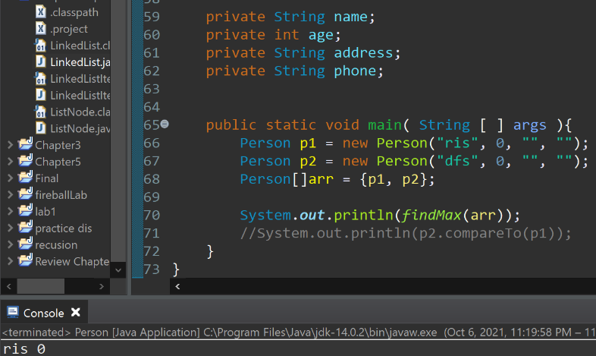

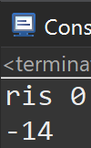

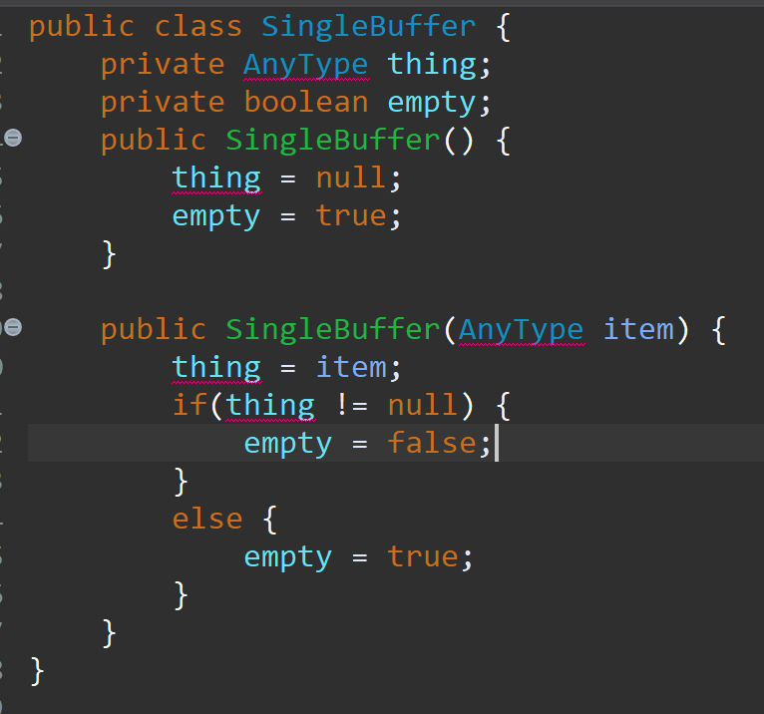**4.37:**

Honestly didn’t work and I’m not to sure how to do it. But this is what I had